Conceptual contribution

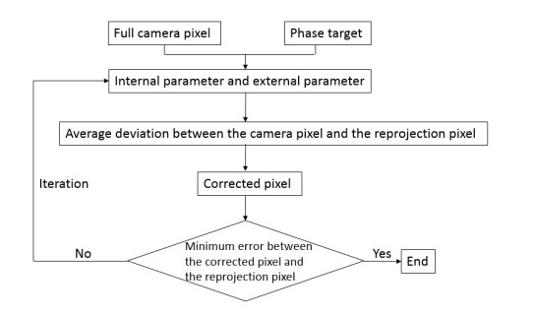

Summary zhang

1. Print a pattern and attach it to a planar surface.

2. Take a few images of the model plane under different

orientations by moving either the plane or the camera.

3. Detect the feature points in the images.

4. Estimate the five intrinsic parameters and all the extrinsic

parameters using the closed-form solution, as described in

Section 3.1

5. Refine all parameters, including lens distortion parameters, by minimizing (10).

0. Generate dataset of images by using the Calibration Pattern in different views

1. Generate Hough lines and separate horizontal from vertical

2. From the hough lines, get rid of duplicate lines and then find intersection of horizontal and vertical lines to get corners corrdinates on image plane

3. Generate world coordinates of the corresponding corners in the image plane

4. Find Homography H between world plane Z=0 and image plane

5. Using this homography and the image of absolute conic, solve equations to estimate the image (omega) of the absolute conic.

6. Using the relationship between omega and K, obtain the intrinsic parameter matrix K. This is a estimate and will be refined further

7. Now, build an initial estimate of R and t matrices using K and H

8. Condition matrix R to be orthonormal

9. Convert the matrix R to a vector R_vec using Rodrigues formula

10. Build initial estimate of all the parameters, 5 for K, 3*no_of_images in dataset for R and 3*no_of_images_in_dataset for t

11. If incorporating radial distortion, the also include parameters k1 and k2

12. Optimize the geometric error between the actual corners and projected coordinates of world coordinates in the image plane using Levenberg - Marquardt algorithm

13. Rebuild the matrices R, t for each image from the 1D vector obtained after optimization. Note that the R_vect should be converted to R matrix using Rodrigues formula

14. Rebuild estimated K matrix from 1D vector after optimization